Education technology

Together, technology and teachers can revamp schools
How the science of learning can get the best out of edtech
Jul 22nd 2017

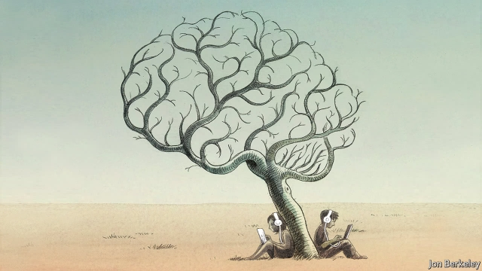
IN 1953 B.F. Skinner visited his daughter’s maths class. The Harvard psychologist found every pupil learning the same topic in the same way at the same speed. A few days later he built his first “teaching machine”, which let children tackle questions at their own pace. By the mid-1960s similar gizmos were being flogged by door-to-door salesmen. Within a few years, though, enthusiasm for them had fizzled out.
Since then education technology (edtech) has repeated the cycle of hype and flop, even as computers have reshaped almost every other part of life. One reason is the conservatism of teachers and their unions. But another is that the brain-stretching potential of edtech has remained unproven.
Today, however, Skinner’s heirs are forcing the sceptics to think again (see article). Backed by billionaire techies such as Mark Zuckerberg and Bill Gates, schools around the world are using new software to “personalise” learning. This could help hundreds of millions of children stuck in dismal classes—but only if edtech boosters can resist the temptation to revive harmful ideas about how children learn. To succeed, edtech must be at the service of teaching, not the other way around.
Pencils down
The conventional model of schooling emerged in Prussia in the 18th century. Alternatives have so far failed to teach as many children as efficiently. Classrooms, hierarchical year-groups, standardised curriculums and fixed timetables are still the norm for most of the world’s nearly 1.5bn schoolchildren.
Too many do not reach their potential. In poor countries only a quarter of secondary schoolchildren acquire at least a basic knowledge of maths, reading and science. Even in the mostly rich countries of the OECD about 30% of teenagers fail to reach proficiency in at least one of these subjects.
That share has remained almost unchanged over the past 15 years, during which billions have been spent on IT in schools. By 2012 there was one computer for every two pupils in several rich countries. Australia had more computers than pupils. Handled poorly, devices can distract. A Portuguese study from 2010 found that schools with slow broadband and a ban on sites such as YouTube had better results than high-tech ones.[…]

